表題Title：
Distribution of a Conspicuous Terrestrial Hydrophilid Beetle Cercyon lineolatus (Motschulsky) (Coleoptera, Hydrophilidae, Sphaeridiinae)

ランニングタイトルRunning title：
Distribution of Cercyon lineolatus

著者連絡先Address of corresponding author：
蓑島悠介
805-0071 福岡県北九州市八幡東区東田2-4-1
北九州市立自然史・歴史博物館
E-mail: xxxx@xxxxx

原稿ページ数 Number of sheets：
4 ページ

付図の点数および印刷方法の希望 Number and printing method(s) of figures ：
２点 （カラー colour：Fig. 1 ；モノクロ monochrome: Fig. 2）

別刷部数 Number of offprint requested：
表紙ありwith front cover : 10 部; 表紙なしwithout front cover: 0部

Distribution of a Conspicuous Terrestrial Hydrophilid Beetle Cercyon lineolatus (Motschulsky) (Coleoptera, Hydrophilidae, Sphaeridiinae)

Yûsuke N. Minoshima ¹⁾, Martin Fikáček ^{2), 3)} and Masahiro Ôhara ⁴⁾

¹⁾ Kitakyushu Museum of Natural History & Human History, 2−4−1 Higashida, Yahatahigashi-ku, Kitakyushu-shi, Fukuoka, 805−0071 Japan
²⁾ Department of Entomology, National Museum, Cirkusová 1740, CZ−193 00 Praha 9−Horní Počernice, Czech Republic
E-mail: mfikacek@gmail.com
³⁾ Department of Zoology, Faculty of Science, Charles University in Prague, Viničná 7, CZ–128 44 Praha 2, Czech Republic
⁴⁾ The Hokkaido University Museum, Hokkaido University, Sapporo, 060–0810 Japan

Abstract New collecting records of a terrestrial hydrophilid beetle, Cercyon (Clinocercyon) lineolatus (Motschulsky, 1863) are provided. This species is easily distinguished from other terrestrial hydrophilid beetle by its large body size and the coloration of elytra. Consequently, the species is newly recorded from Bangladesh, Japan, Malaysia, Nepal, Laos, Singapore, Thailand, and Palau.

Key words: Water scavenger beetle, new record, Oriental, Palaearctic, Oceania.

Introduction
A terrestrial hydrophilid beetle Cercyon (Clinocercyon) lineolatus (Motschulsky, 1863) is a member of the tribe Megasternini (Sphaeridiinae), and is well distinction from other representatives of the genus Cercyon by the longitudinal yellow stripes on elytra and large body size. The species is widely distributed in tropical and subtropical Asia, but was also found in Arabian Peninsula and on Mascarene Islands (Hansen, 1999; Fikáček et al., 2010; Fikáček et al., 2015). We had opportunities to examine specimens of this terrestrial hydrophilid beetle, which represent additional or first record of the species from several Oriental and Oceanian countries. In this paper, we provide collecting records of C. lineolatus from Oriental Region and Oceania.

Material and Methods
Materials are deposited in the following collections: Kitakyushu Museum of Natural History & Human History (Y. Minoshima) (KMNH); National Museum, Praha, Czech Republic (M. Fikáček) (NMPC); Naturhistorisches Museum, Wien, Austria (M. A. Jäch) (NHMW); Systematic Entomology, Hokkaido University, Sapporo, Japan (M. Ôhara) (SEHU); Ehime University Museum, Matsuyama, Ehime, Japan (H. Yoshitomi) (EUMJ); private collections of Andre Skale, Hof, Germany (ASCH) and Shun’ichi Sakurai, Sakata, Japan (SSCS).
The methods generally follow those used by Minoshima and Fujiwara (2009). Composite images were created using the software Image Stacking Software CombineZP (Hadley, 2010). The photographs were modified using Adobe Photoshop CC in needed case. Regarding the morphological terminology, we follow Hansen (1991).

Results

Cercyon (Clinocercyon) lineolatus (Motschulsky, 1863)
(Figs. 1–2)

Trichopoda lineolata Motschulsky, 1863: 444.
Cercyon lineolatus (Motschulsky): Gemminger & Harold, 1868: 497.
Cercyon (Clinocercyon) lineolatus (Motschulsky): Bameul, 1986: 889.
Cercyon nigrostriatus Wu et Pu, 1995 in Jia et al., 1995: 127. Syn. by Jia et al. (2011).

Material examined. Bangladesh ––– 1 ex. (NMPC), East Pakistan, Dinajpur, X.1969, Barbe leg. China ––– 2 exs. (KMNH), Yunnan prov., 50 km N Jinghong, env. Gunangping, 950 m, 11–20.XI.2004, S. Murzin leg.

Diagnosis. Body (Fig. 1) elongate oval, moderately convex. Dorsal surface weakly lustre; ventral surface mostly lustreless dark brown. Pronotum black with broad yellowish lateral margin. Elytra bicoloured, black with light yellowish brown stripe among serial punctures and lateral margin (Fig. 1).

Biology. Bameul (1986) mentioned the species inhabits cow and rabbit excrement.
Distribution. Palaearctic: United Arab Emirates, China, Japan (Yonaguni-jima Island, Ishigaki-jima Island) (Fikáček et al., 2010; Jia et al., 2011; and this study). Oriental: Bangladesh, India (Bihar, Maharashtra, Meghalaya, Rajasthan), Indonesia (Sumatra, Sulawesi), Laos, Malaysia (Borneo), Nepal, Philippines, Singapore, Sri Lanka, Taiwan, Thailand, Vietnam (Orchymont, 1928; Hansen, 1999; and this study).

Acknowledgements
We thank Manfred Jäch (NHMW), Hiroyuki Yoshitomi (EUMJ), Andre Skale (Hof) and Shun’ichi Sakurai (Sakata), who kindly provided/lent us the specimens. This study was partly supported by the Ministry of Culture of the Czech Republic (DKRVO 2016/14, National Museum, 00023272) to M. Fikáček.

要 約
蓑島悠介・Martin Fikáček・大原昌宏：特徴的な陸生ガムシCercyon lineolatus (Motschulsky)（鞘翅目ガムシ科）の分布．––– ケシガムシ属Cercyonの一種シマケシガムシ（和名新称）Cercyon (Clinocercyon) lineolatus (Motschulsky, 1863)は，本属の中では大型種であること，上翅に特徴的な黄色の縦縞模様を持つことから容易に他種と区別される．

References

Bameul, F., 1986. Les Hydrophiloidea des îles Mascareignes (Coleoptera). Revue suisse de Zoologie, 93: 875–910.
Fikáček, M., R. B. Angus, E. Gentili, F.-L. Jia, Y. N. Minoshima, A. Prokin, M. Przewoźny & S. K. Ryndevich, 2015. Family Hydrophilidae Latreille, 1802. Pp. 37–76. In Löbl, I., & D. Löbl (eds.), Catalogue of Palaearctic Coleoptera, 2. Hydrophiloidea – Staphylinoidea. Revised and updated edition. 1702 pp. Brill, Leiden / Boston.

Manuscript received dd mm yyyy;
revised and accepted dd mm yyyy.

Figure captions
Fig. 1. Habitus of Cercyon lineolatus (Motschulsky, 1863). ––– A, Dorsal view; B, lateral view; C, ventral view.
Fig. 2. SEM photographs of Cercyon lineolatus (Motschulsky, 1863). ––– A, Head and pronotum, dorsal view; B, elytra, dorsal view; C, meso- and metaventrite and abdomen, ventral view; D, head, ventral view; E, prosternum, ventral view; F, mesoventral tablet, ventral view; G, metaventrite, ventral view.

画像については、別ファイルとして画素数の高いものを必ず用意してください。以下のように、ワードなどに貼付けた画像は、印刷に耐えられないためです。ただし、以下のように原稿ファイルに画素数の軽いものを参考までにつけていただくことは、問題ございません。査読者へまわす際には便利ですので、編集者は助かります。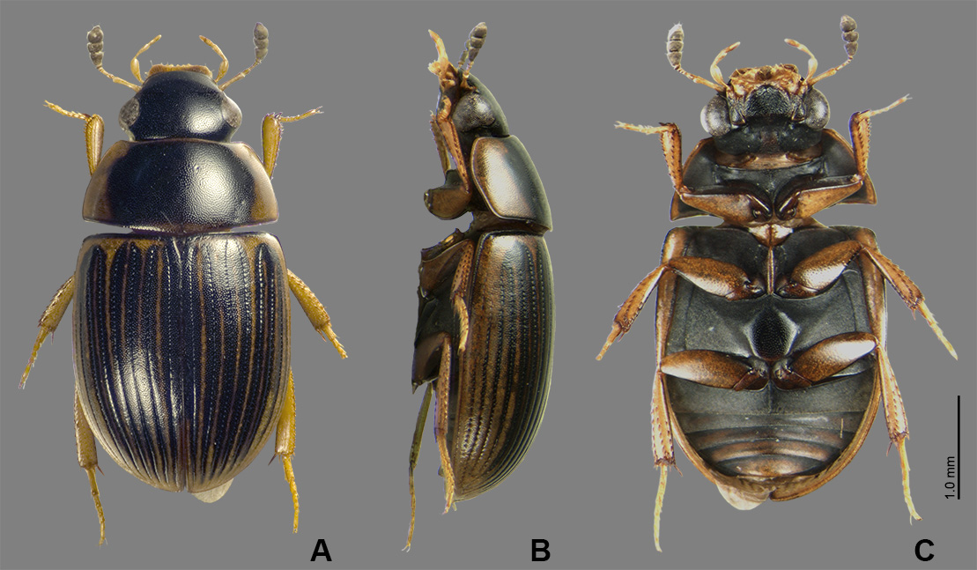
Fig. 1. Habitus of Cercyon lineolatus (Motschulsky, 1863). ––– A, Dorsal view; B, lateral view; C, ventral view.

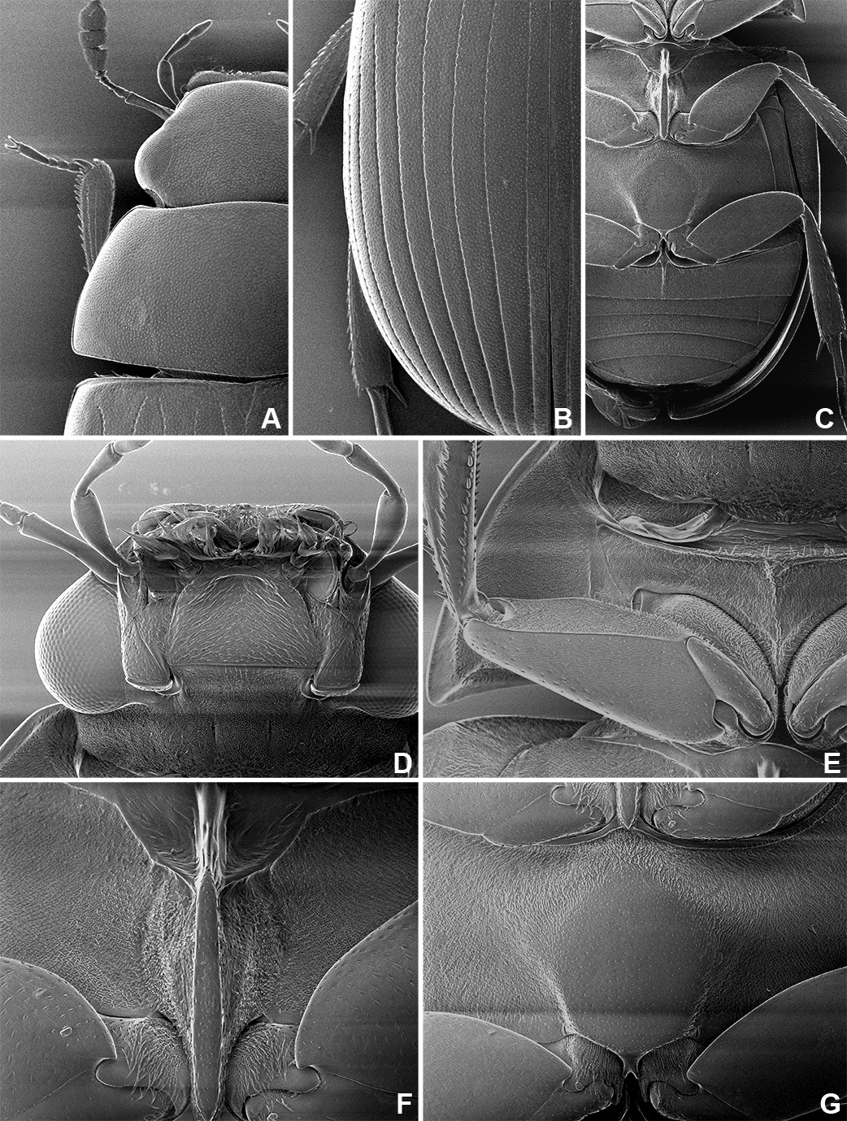
Fig. 2. SEM photographs of Cercyon lineolatus (Motschulsky, 1863). ––– A, Head and pronotum, dorsal view; B, elytra, dorsal view; C, meso- and metaventrite and abdomen, ventral view; D, head, ventral view; E, prosternum, ventral view; F, mesoventral tablet, ventral view; G, metaventrite, ventral view.

